**Assignment 6**

Each of the following 5 charts has one or more problems. Identify and list the problems and suggest fixes (in a couple of lines) for the following charts.

Note that the fixes can be modifications to existing charts and/or suggestions to use a different chart.

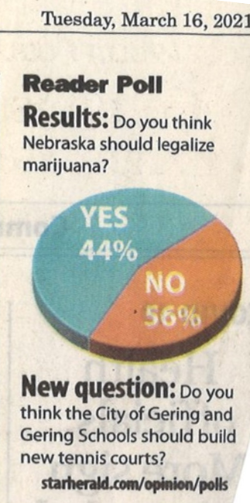**Chart 1**: List at least 2 problems and suggest modification(s).

**Chart 2**: This chart is meant to be a visualization of how many hours of overtime the salaried staff of a company took in 2020. A table will be more informative. (i) Hand create a table and (ii) suggest an alternative informative chart based on the tabular data.

**Chart 3**: This chart is meant to show the salary range in certain profession: There are at least two problems in this chart. Suggest updates.

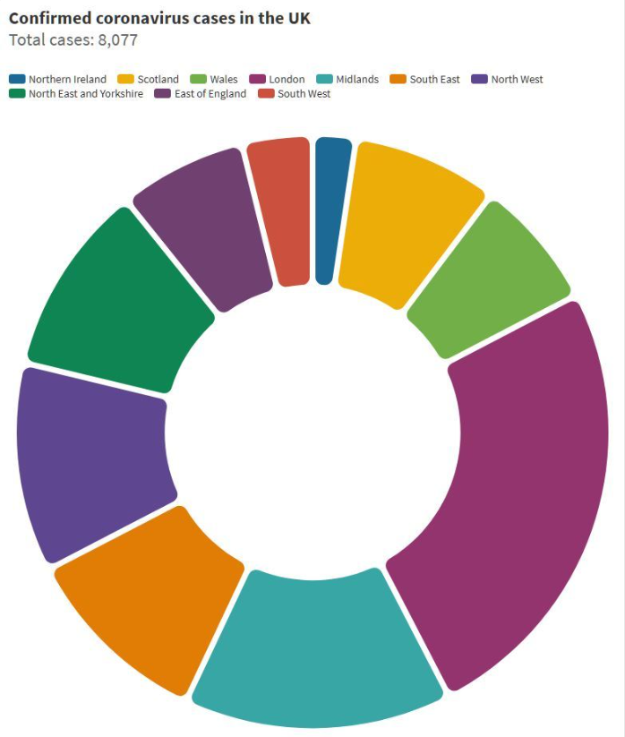**Chart 4**: What are the two main problems with this chart? Suggest a better alternate chart.

**Chart 5**: Pareto chart uses two scales and combines a bar chart with line chart in a single chart. However, this is not a Pareto chart. Why? What will be an alternative to this plot?